CO226 Project Proposal

Hostel Management System

Group No: 10

**Members**

Aslam MMM (E/15/021)

Mohammed MHH (E/15131)

Suhail S (E/15/348)

**Overview**

In hostels all the records are recorded in books and only the hand-written records are maintained. When disadvantages of following this system are Data isolation, Time Consuming, Redundant Data and it is very tedious task to do process like search and sort.

Accommodation division controls all the hostels. But they don’t have a centralized database and up-to-date data about the hostels.

Hostel still do the registration manually. Due to this it takes lots of time and manpower to do the registration.

As a solution to these problems, building a computerized database for accommodation division has been decided as our CO226 project.

In this project proposal the goals, specifications, and Future Improvements are described as following.

**Goals**

* Build a database such that to maintain,
  + All the records about students who are using hostels
  + Records about hostels
  + All the records of employees working for accommodation division
  + All the records about labors who are working in hostels
* Build a web portal for registration process.

**Specifications**

* Records of the students can be easily managed by hostel administration.
* Hostel Administration can easily calculate the fine amount that student has to pay
* Records of the labors can be easily managed by hostel administration.
* Records about Hostels and records about Hostel administration can be easily managed by hostel administration.
* Students can easily do the registration process through web portal.

**Future Improvements**

* Improve this database for all the divisions of the university.
* Improve the security of the database
* A web portal for complains and suggestions

**ERR Diagram**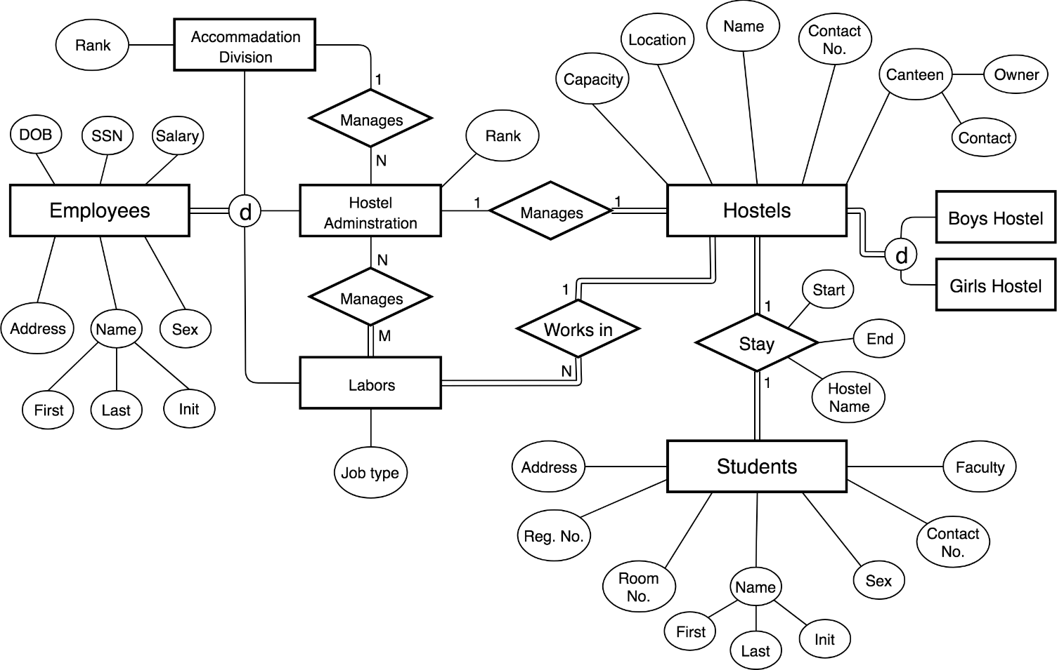

**Timeline**